EXPERINMENT NO 4
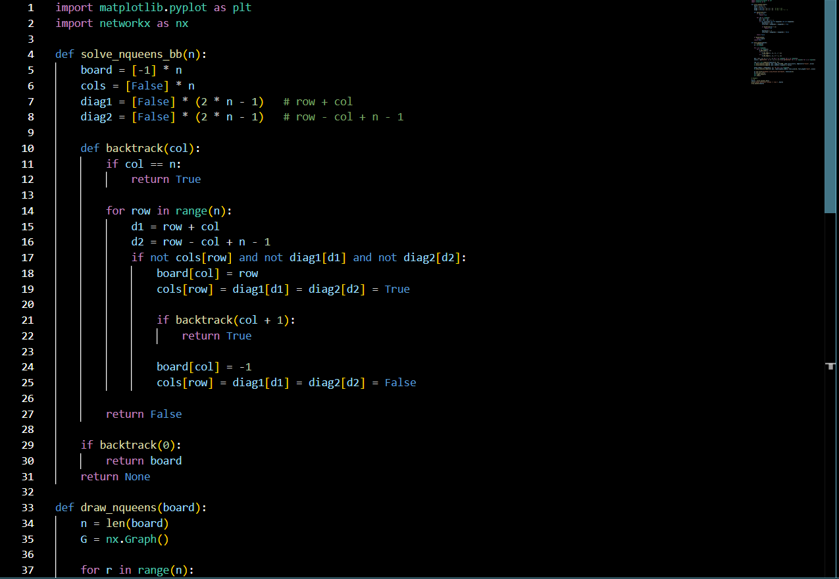
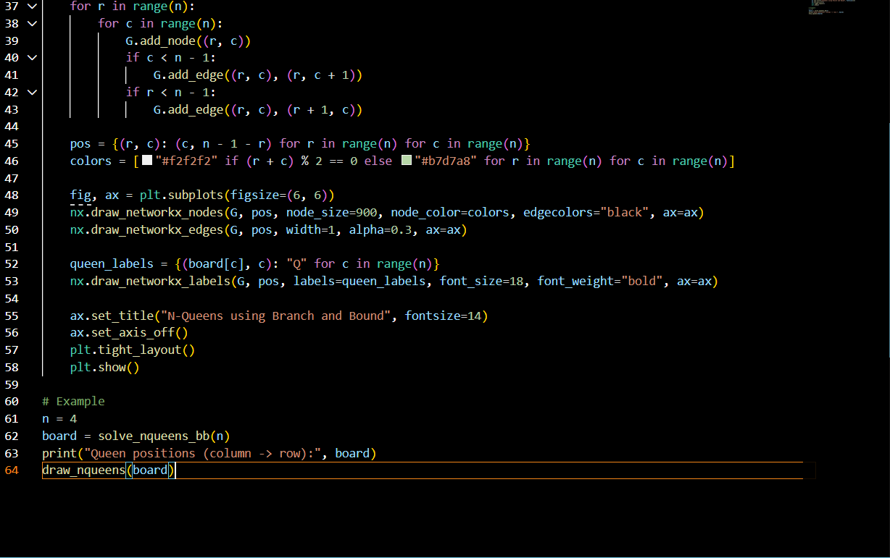
Implement a solution for a Constraint Satisfaction Problem using Branch and Bound and Backtracking for n-queens problem or a graph coloring problem.
